**Machine Vision Classroom Attendance**

Machine Vision | SKEM 4133 | Project Report | Group 9

**Group Members:**

Amr Ahmed Abdelsattar – A16KE4004

Mohanad Salem Omar Alqushairi – A16KE4015

Syed Salman Rahman – A16KE4012

1. **INTRODUCTION**

Most workplaces use attendance system in its various types, advanced or classic ones. For universities passing an attendance sheet from one student to the other to sign takes time as well as causes distraction. Some lecturers may tend to wait till the end of the class for signing rather than causing distraction in the lecture room. When dealing with lectures that have large number of students, it’s difficult and a task that consumes time either from the lecturer himself or the students. Some lecturers become careless about attendance due to the distraction caused by it, and just leaving the students with their own maturity on choosing to attend classes or not. In other cases, some students can be manipulative when signing the attendance sheet, either by signing for their friends or signing then leaving the class.

There are various methods that can be usable for improvements in the attendance systems in general, however each method has its pros-and-cons. Some methods are better than the manual signing, but lacks efficiency such as barcode scanning where attendance can be manipulated too. In this project the proposed system is an attendance management which recognizes faces and compares it to the dataset, which is has captured images before training to check for availability. The system may have limitations due to the type of camera and skin tone.

* 1. **BACKGROUND**

The faced problem of attendance system had been faced by most lecturers around the globe, and a solution had to be found. There have been many proposals to optimize the students’ attendance management in higher educations. Different researchers came out with different solutions that can be useful, depending on the requirements. Each system has its pros and cons, which are taken into consideration. Researchers tend to develop new methods to improve available systems, or come out with new methods that have higher efficiency rate compared to other methods. There is a compelling need for a well-designed attendance management system so that the records of their participation are efficiently managed.

* + 1. **Haar Cascaded Classifier**

Quite a few number of machine learning processes have the capability of having a greater computational ability to detect objects but the generic detectors almost always have a better performance in terms of scale, shape and localization. Haar cascade which is one of the tree-based methods in which at training phase, a statistically booster rejection classifier is created. The Boosting potential is that a strong classifier is created from a series of weak classifiers and a weak classifier gets the classification correctly at the increasing weight on samples that are misclassified so that on the next iteration of the training corrects the falsely classified samples. In the final part a convex combination of all hypotheses are computed [6].

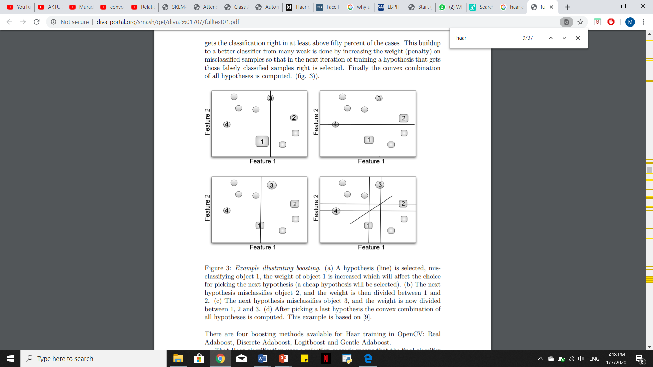

**Figure 1**: Example illustrating boosting. (a) A hypothesis (line) is selected, misclassifying object 1, the weight of object 1 is increased which will affect the choice for picking the next hypothesis (a cheap hypothesis will be selected). (b) The next hypothesis misclassifies object 2, and the weight is then divided between 1 and 2. (c) The next hypothesis misclassifies object 3, and the weight is now divided between 1, 2 and 3. (d) After picking a last hypothesis the convex combination of all hypotheses is computed.

* + 1. **Local Binary Pattern Histogram**

LBP algorithm stands as a gray level within the scope of the texture measure and which allows it to support the localized contrast measure of the image. Eight Pixels are usually defined in the neighborhood. Central pixel gray value is depict as the threshold. All neighbors’ value are either higher or equal to the central pixel. The value is set to either 0 or 1. The values will be multiplied with pixel weight after thresholding and the summation of these values will be the LBP value [7]. The calculation principle of original LBP is shown in Fig. 2.

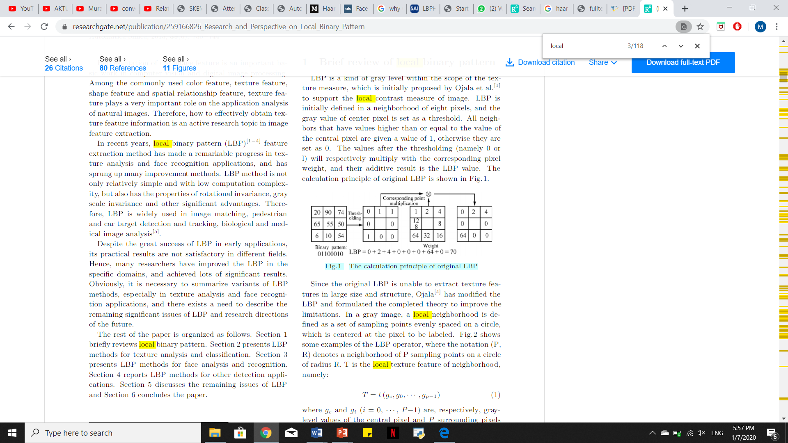

**Figure 2**: The calculation principle of original LBP

This method adopted the Adaboost to learn the most discriminative sub-regions (in term of LBP histogram) from a large pool of sub-regions generated by shifting and scaling a sub-window over face images [7].

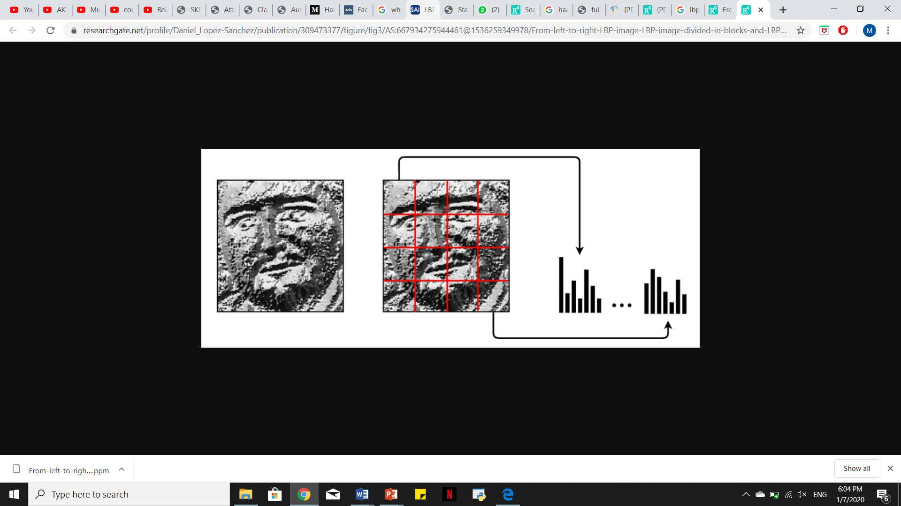

**Figure 3**: The formulation of LBPH

* 1. **Related Work**

Upon research, several facial recognition systems has been explored. Some of which were even found to be sharing a similar objective where the facial recognition system was utilized for the purpose of recording attendance. In [1], a mobile device based application was developed to record attendance via taking individual pictures of the users. The proposed solution provided two methods for recording attendance. First, the device was passed to the users to take individual pictures of themselves while confirming their identity. Involving the user in the system to issue confirmation, although cumbersome, ensured that the recorded attendance is of no errors. The application provided an alternative as well – attendance via signature. The user in this scenario will be asked to sign on the mobile device’s screen by the finger. The attendance was then recorded based on the identification of this signature by comparing it to the pre-registered samples. This method still was utilizing image processing for identification yet it provided a more private alternative to the user.

Other systems explored provided an insight in facial recognition techniques. In [2] for example, the proposed system was based on histogram algorithm – which require an immense amount of positive as well as negative images in order to train the classifier. The system adapted the architecture viewed in figure 4. Using a camera, an image of the user was captured then uploaded. Based on this image, segmentation of the user’s face was then done. Afterwards, the face of the user was then detected by using Haar cascade algorithm. The users face was then identified by the trained dataset using histogram values. Attendance was eventually recorded in case the user was enrolled in the database.

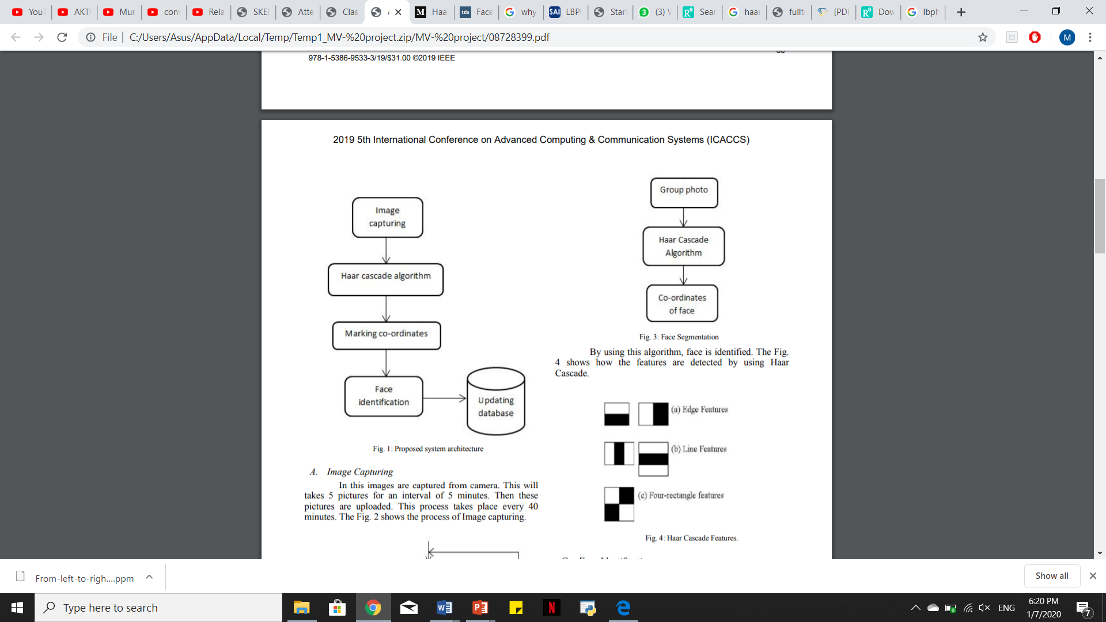

**Figure 4**: Proposed system architecture

* 1. **PROBLEM STATEMENT & OBJECTIVEs**

Manual attendance process wastes time, even if the lecturer asks the students to sign after the class ends, the students may be late for the next class. During lectures it’s really hard for a student to focus if the attendance sheet is roaming through the class for each person to sign, the distraction caused leave an unhealthy environment during the lecture. Many problems are caused only because of the manual attendance process. Universities restricts students to have above 80% of attendance during the semester, or they are not allowed to have their final exam. When calculating the attendance percentage of each student many may argue about their attendance percentage and because lecture may face the possibility of losing some attendance sheets. The following are the project objective to improve attendance systems:

* To design an effective system able to detect attendance by students’ faces
* Capture images and store into the database
* Tracking of the input image from the dataset to compare with the face detection
* Record students’ attendance with respect to time and date

1. **Project Methodology**

Facial Identification is a process by which a system is capable of identifying a user’s face from an image or from a video. Several classifiers and various techniques can be used to achieve facial identification. As for this project, Haar Cascade classifiers which are based on the Haar Wavelet technique are used. Haar Wavelet Technique is a method of analyzing pixels in the image into squares by function. The classifier basically utilizes “integral image” concepts to compute the features detected [3]. Haar Cascaded classifiers use summed up weak classifiers in order to have strong classifiers. These classifiers can be observed in figure 5 and figure 6 below. Haar features are similar to these convolution kernels which are used to detect the presence of that feature in the given image as shown in figure 7. As for this project, the Haar cascade classifier will be used to extract features from the input training images.

**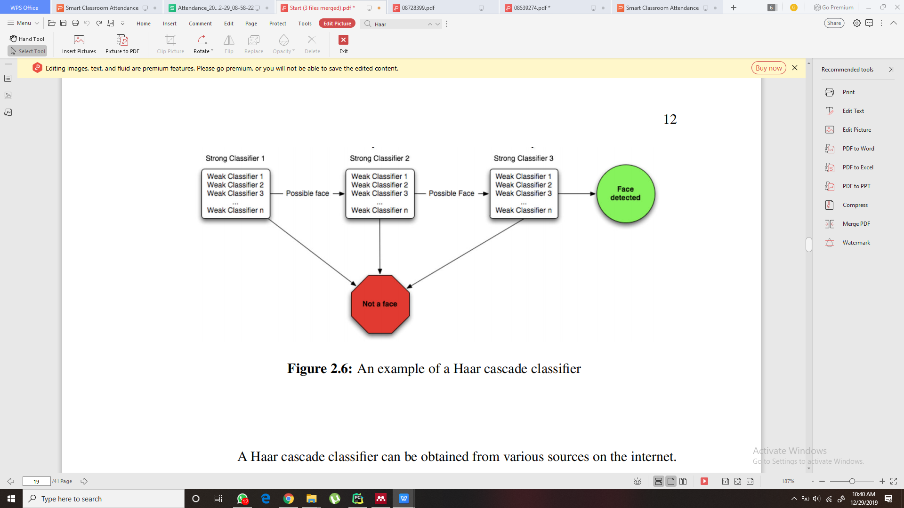**

**Figure 5:** Haar Cascaded Classifier

**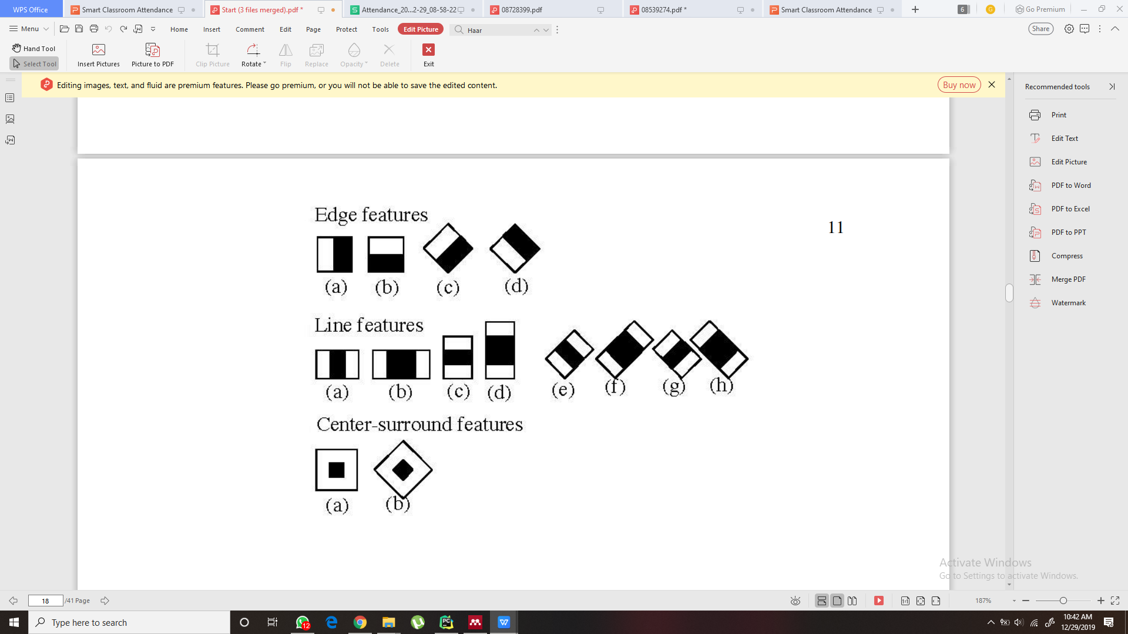**

**Figure 6:** Features used for Haar classifier

**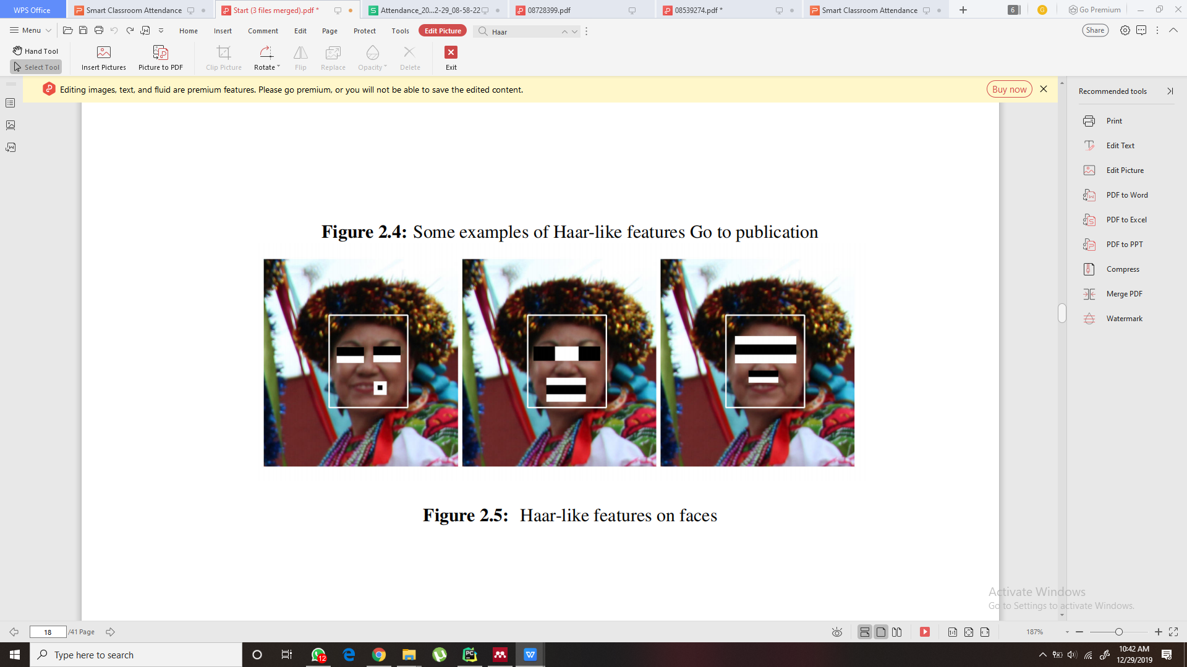**

**Figure 7:** Haar like features on face

**Local Binary Pattern**(LBP) is a simple yet very efficient texture operator. LBP labels the pixels of an image by thresholding the neighborhood of each pixel. Then it considers the result as a binary number. LBP was first introduced in the early1990s and ever since it has proven to be a powerful feature for texture classification. Furthermore, it has been noticed that when LBP is combined with histograms of oriented gradients (HOG) descriptor, some datasets had a huge boost in detection performance. Using the LBP along with histograms, face images can be described with a simple data vector. LBPH is one of the easiest face recognition. Its algorithm is provided by the [OpenCV](https://opencv.org/" \t "_blank) library (Open Source Computer Vision Library) [4].

**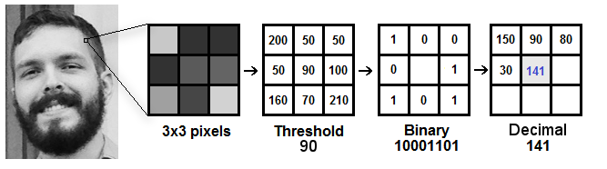**

**Figure 8:** Haar like features on face

**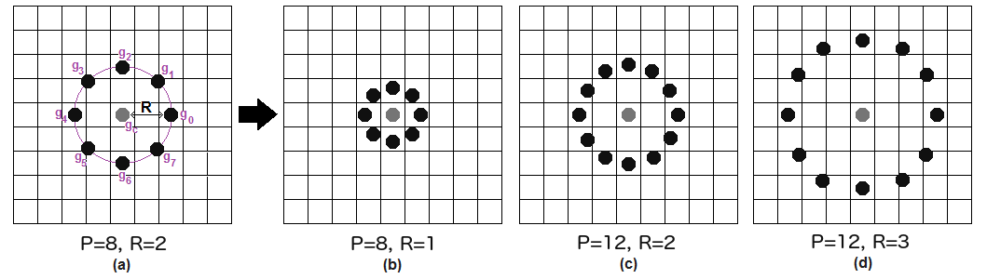**

**Figure 9:** Circular LBP

**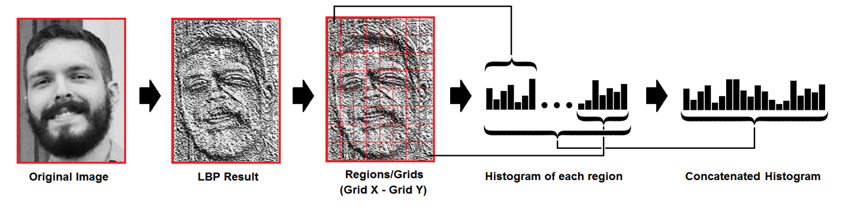**

**Figure 10:** Haar like features on face

**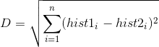**

(1.1)

* 1. **ALGORITHM/SYSTEM DESIGN**

The system starts by capturing an image of the student, then Local Binary Pattern is used to extract image’s features. As it trains the face and stores it into local dataset, while when comparing the images from the database is pulled into an array to compare between the image from the database trained and the input image using the Euclidian equation. The images are compared by the histogram value of each image. If the student’s face is recognized then he is considered as attending the class, and the information about his attendance is stored into the excel file. If not recognized, then the process has to start all over again from capturing the image.

**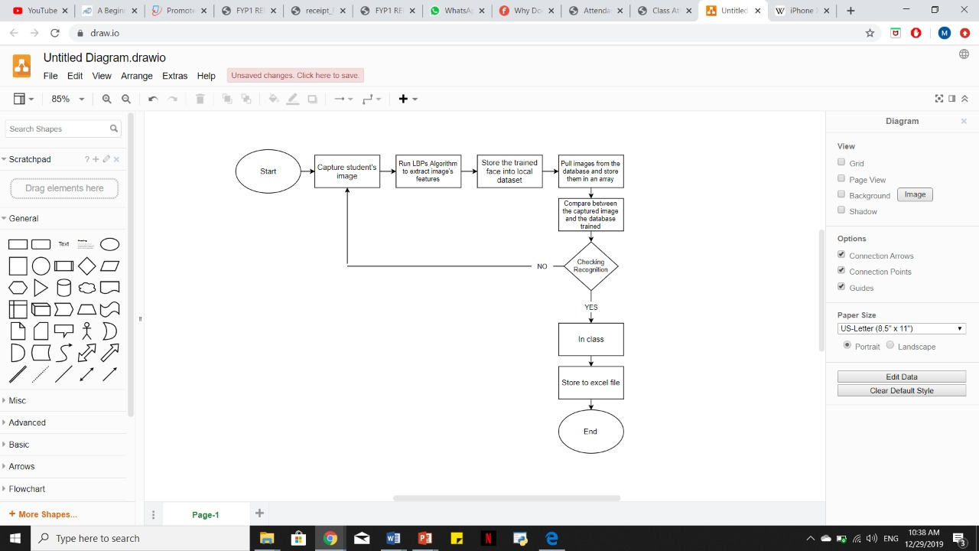**

**Figure 11.** System flow chart

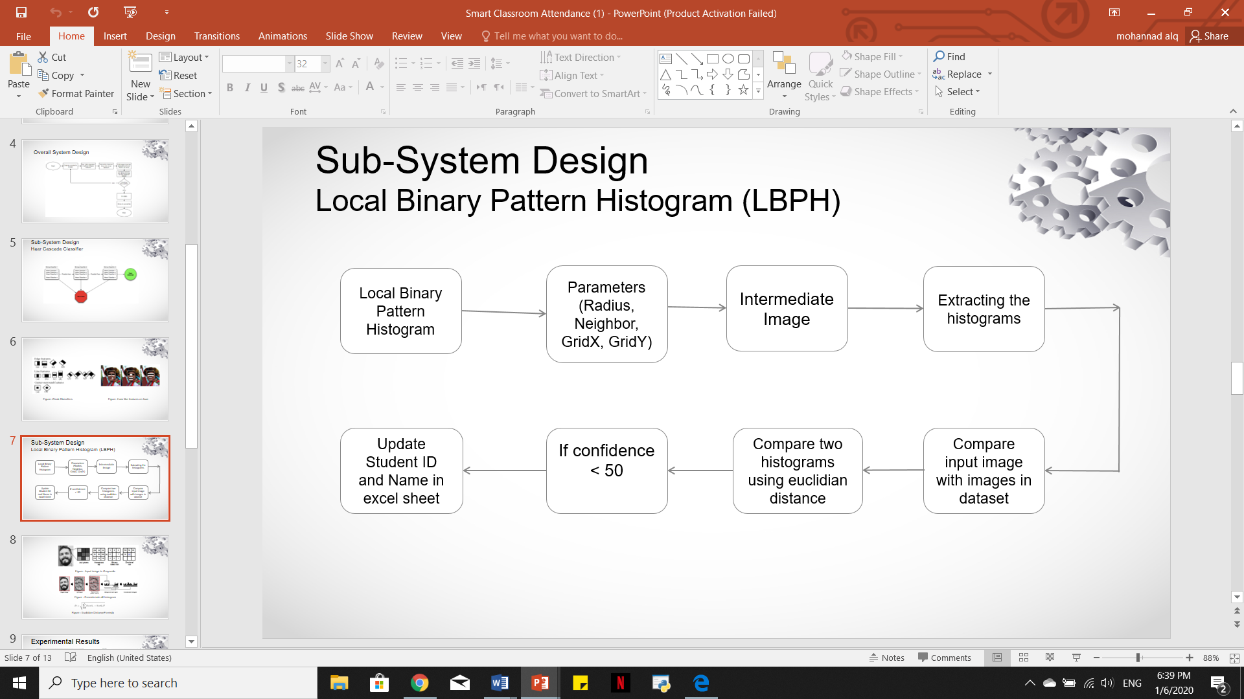

**Figure 12.** Sub-system design (Local Binary Pattern Histogram)

The local binary pattern histogram flow chart is shown in the figure above. The process starts by the parameters that will be used such as radius, neighbors, gridX, and gridY. Then training is compulsory with the face id number and name, after that is the creation of intermediate image and extracting of histograms. The Euclidian distance formula will compare the histogram of the input image and the image from the dataset. The confidence value is set by the moderator, if it’s greater than 50 then the student will be considered in class and the excel file will update with the student’s information.

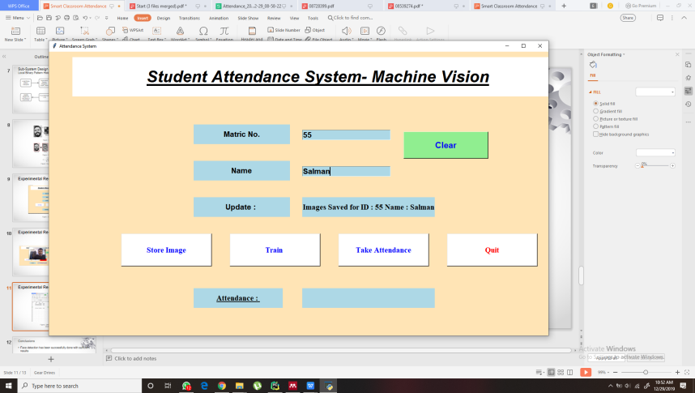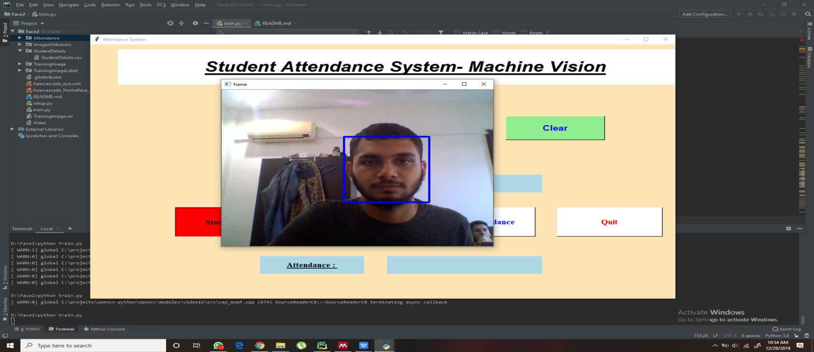

**Figure 13**: Graphics User Interface (GUI) helps to take image to be stored in the dataset.

**Figure 14**: Detection and feature extraction for training

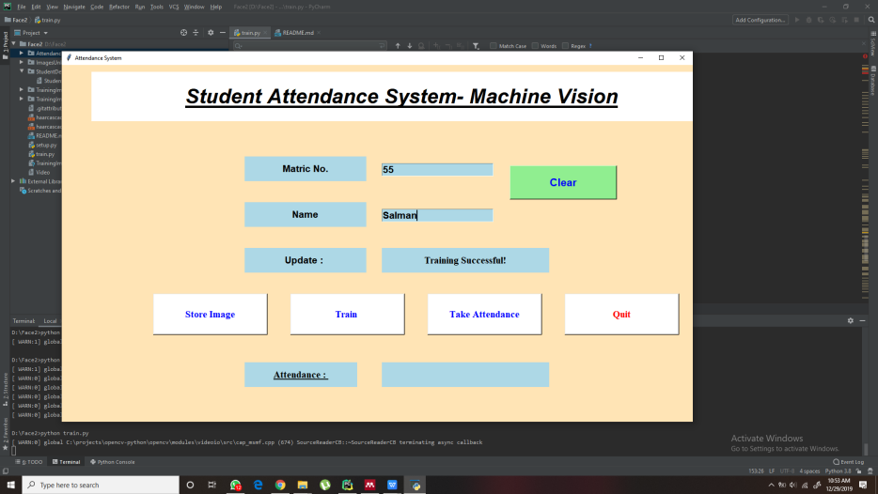

**Figure 15**: GUI shows the training has been done for the images.

**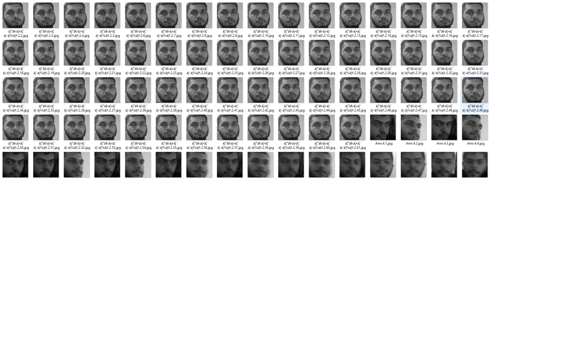**

**Figure 16:** Grayscaleimages stored in the Dataset

**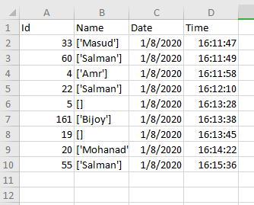**

**Figure 17:** Attendance recorded in an excel sheet as a csv file.

1. **Results**

To verify the functionality and range of the system, few methods were used like:

1. Tested on different people, 2. Tested on different distance and lighting provided, 3. Number of people that can be detected in one frame.

Overview of the test cases are

Case 1: Samples used for this case was 4 persons. The samples had variation of age, skin color, ethnicity, facial characteristic.

Case 2: Distance was varied from 1ft to 2ft. Below or above this range it was either too close or too far for the specific camera ( laptop webcam) to detect faces.

Case 3: People that were already registered in the system were used to do the test. Different arrangements of people were done to verify the functionality.

**Test case 1**

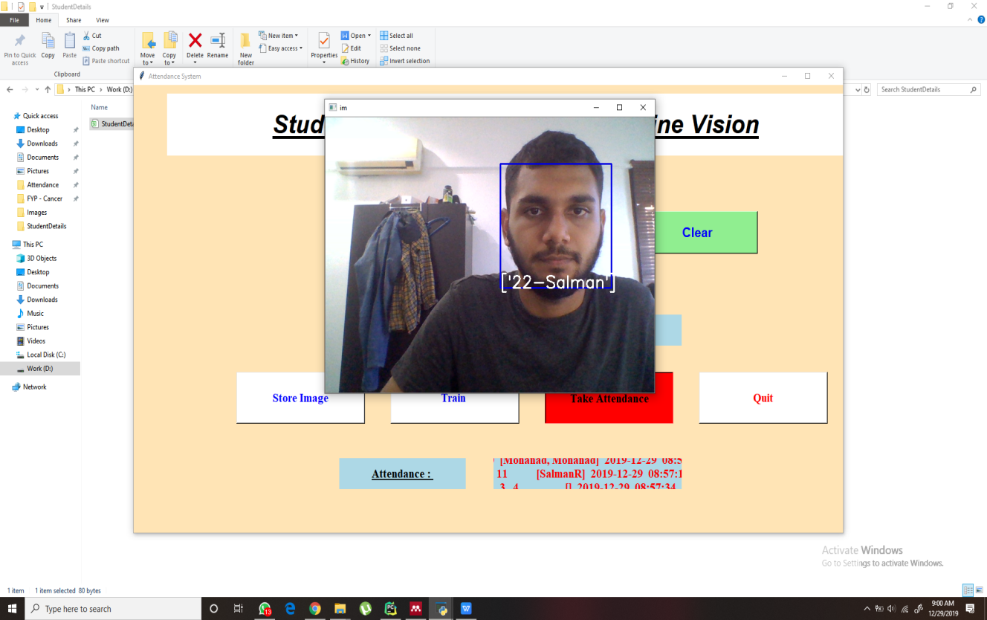

**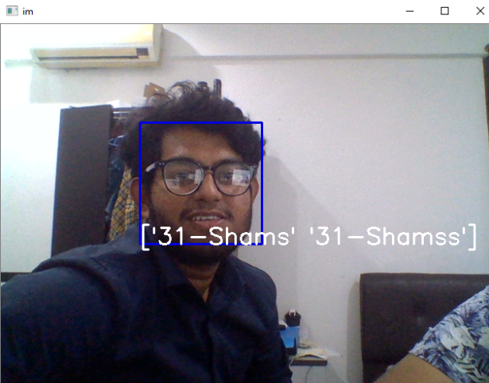**

**Figure 18:** Test on Person 1

**Figure 19:** Test on Person 2

**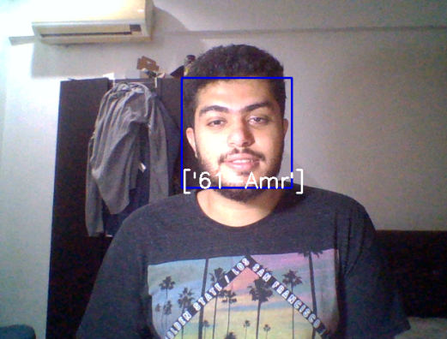 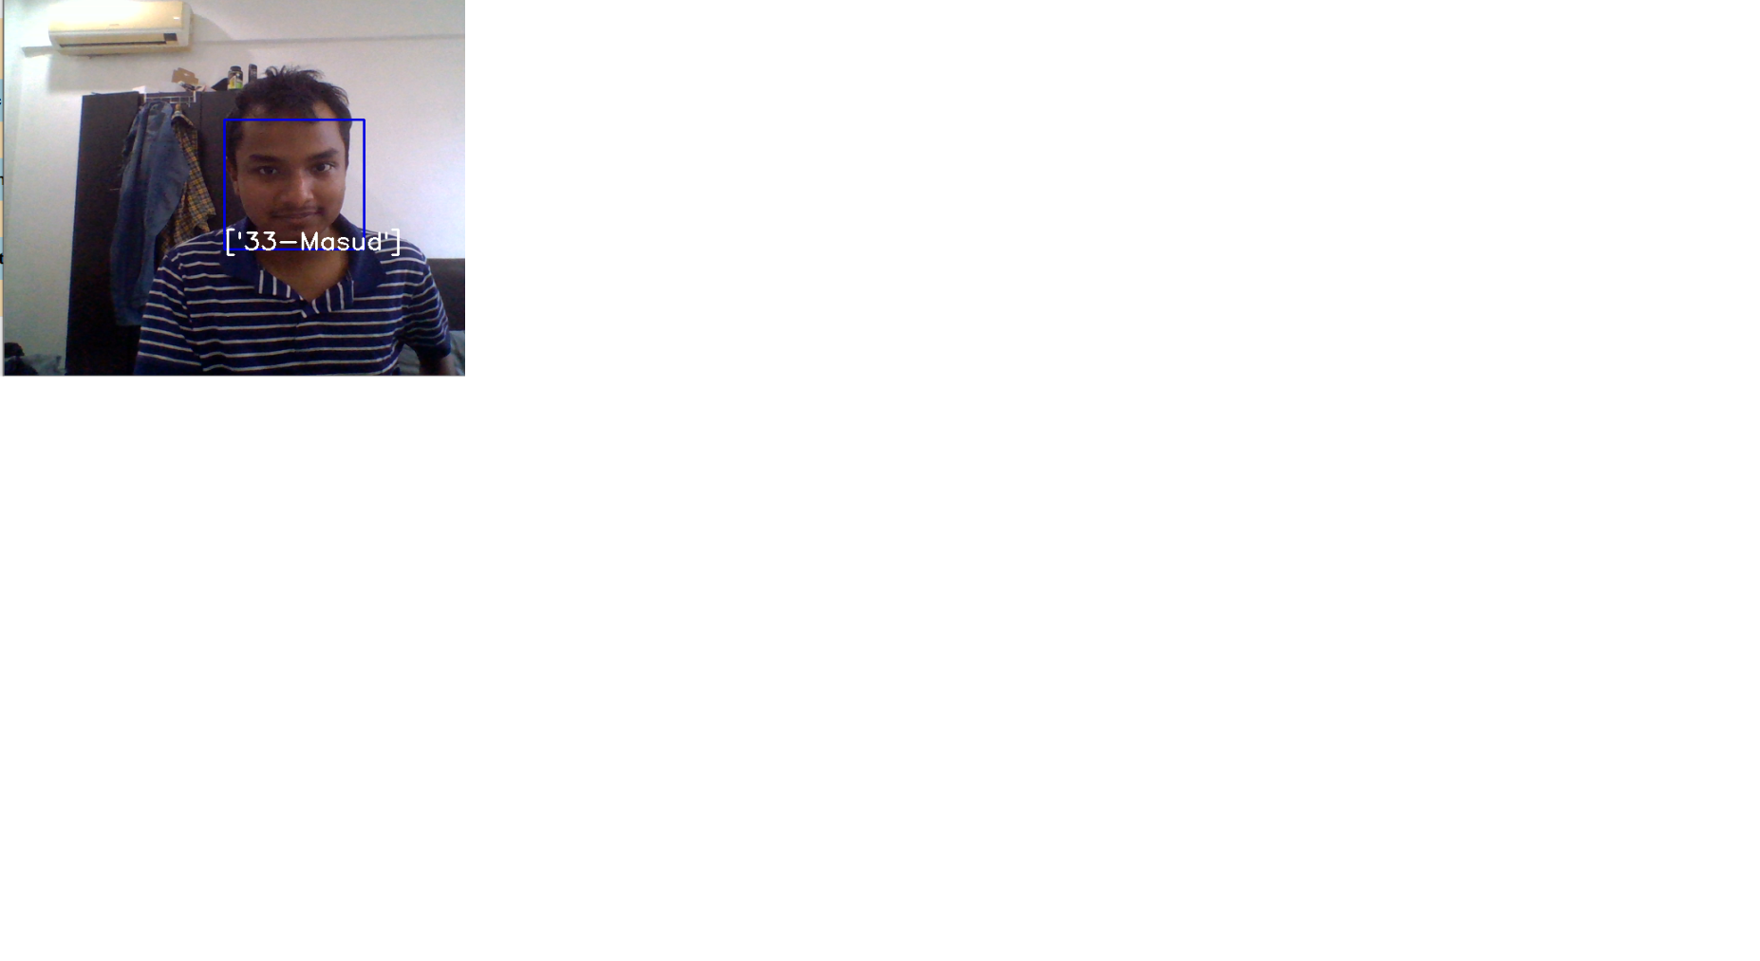**

**Figure 20:** Test on Person 3

**Figure 21:** Test on Person 4

**Test case 2**

**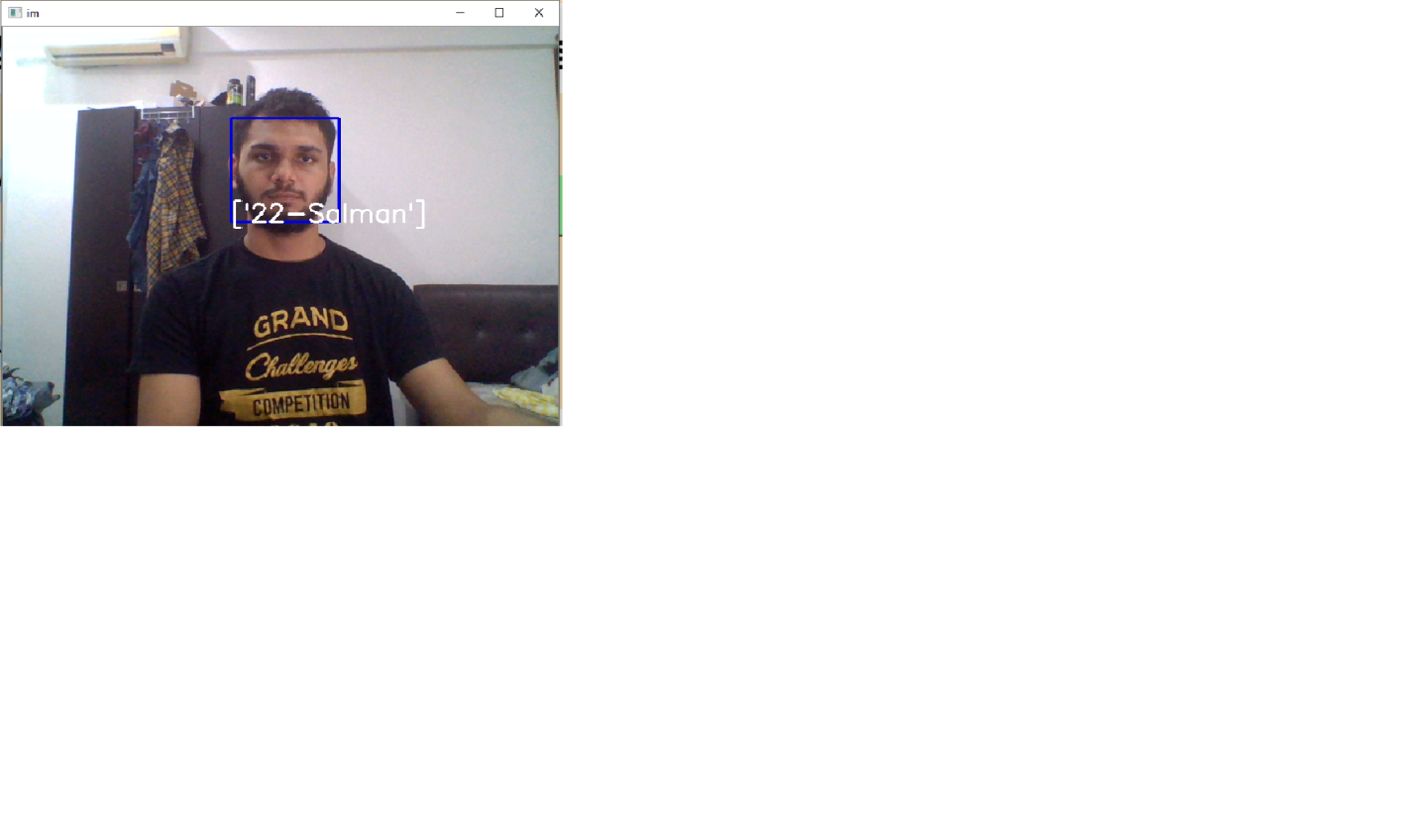 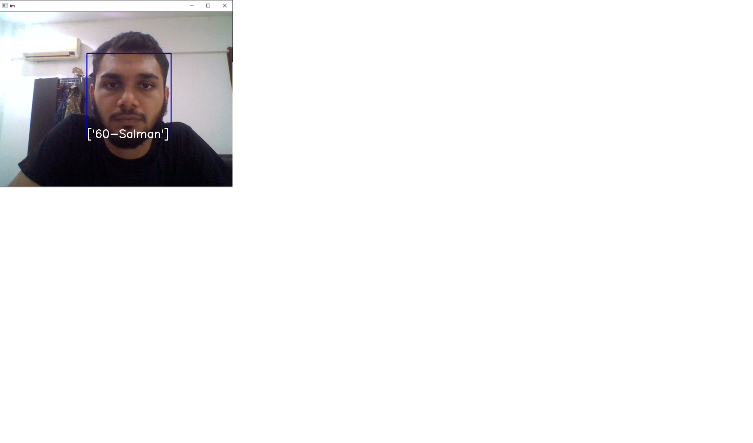**

**Figure 23:** Output when d = 30.48cm or 1ft

**Figure 22:** Output when d = 45.72cm or 1.5ft

** 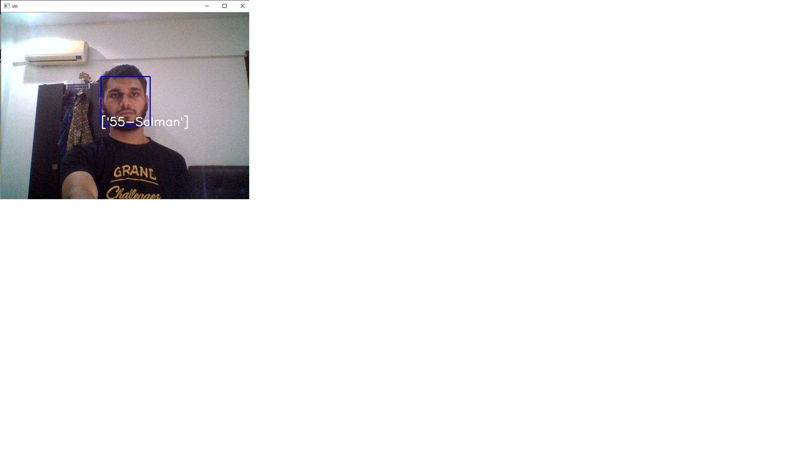**

**Figure 24:** Output when d = 60.96cm or 2ft

**Figure 25:** Output when d = 60.96cm or 2ft. With enhanced lighting.

**Test case 3**

** 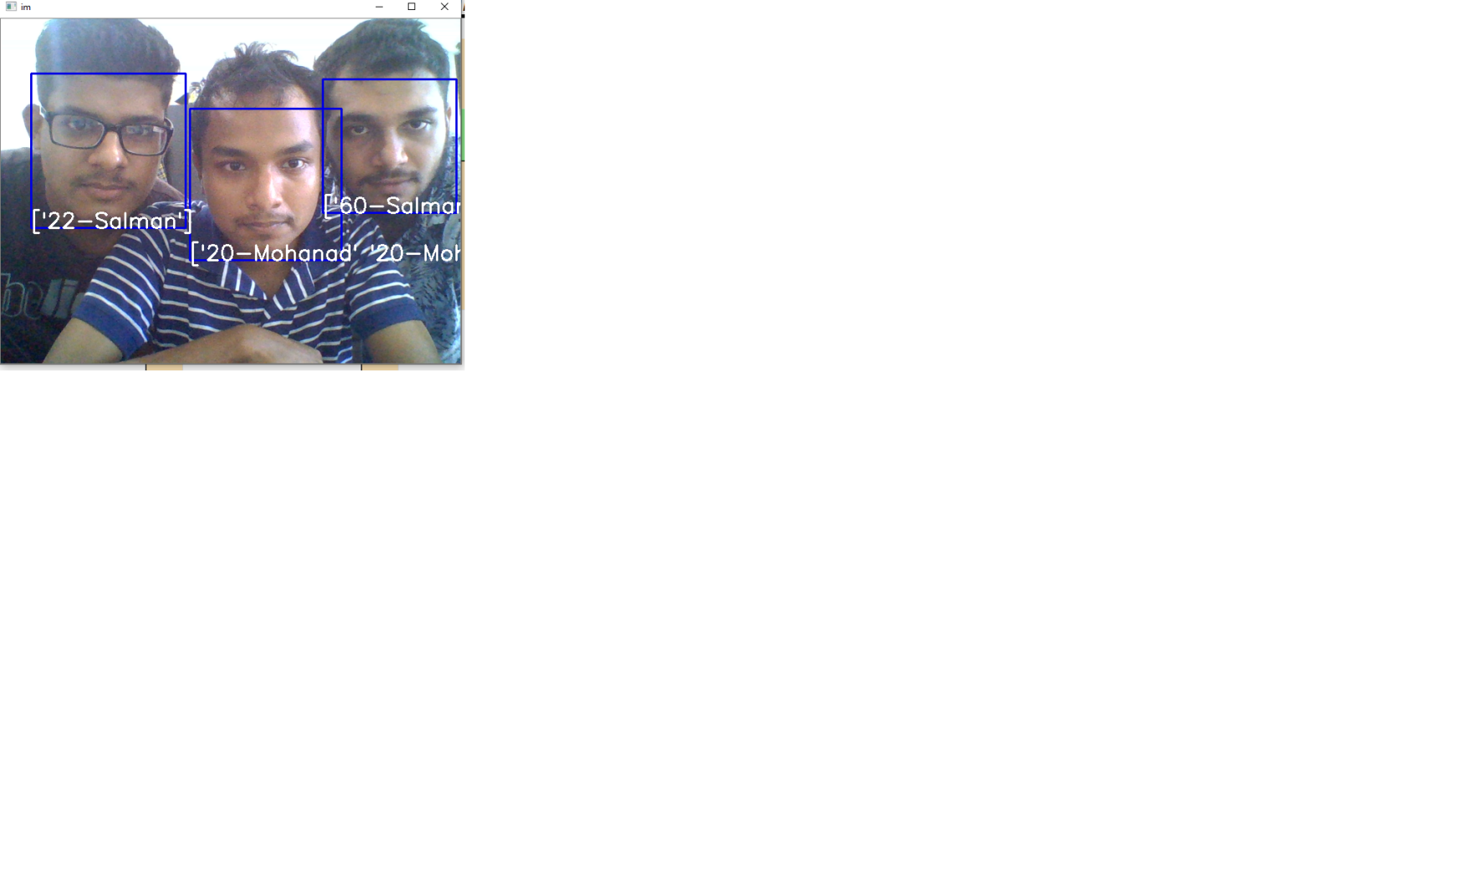**

**Figure 27:** Output when3 persons are in separate ROI

**Figure 26:** Output when 1 person is in the ROI

**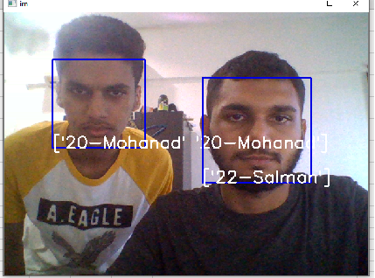 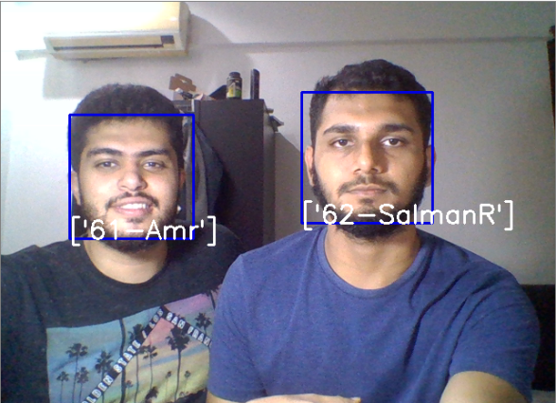**

**Figure 28:** Output when 2 persons are in separate ROI.

**Table 1:** Results from all test cases summarized

|  |  |
| --- | --- |
| **Test case** | **Result summary** |
| **1** | The system successfully detected, extracted features and recognized faces for variety of people with different facial structure, color and characteristics. All images were converted to grayscale and stored in the dataset successfully. |
| **2** | It can be seen that the recognition is optimal when distance of the student from the camera was until 45.72cm or 1.5ft.  Once distance is beyond the optimal limit, the accuracy of the detection and recognition is significantly affected. In this case, enhancing lighting or change in position can make the recognition better. |
| **3** | The results show that the system can easily detect one or two students in two different ROI with ease. On the other hand when 3 or more people want to be detected and recognized at the same time, the accuracy dwindles drastically. |

1. **CONCLUSION**

The Classroom Attendance through Machine Vision has met all its objectives for this project. After images are captured, features are extracted they are stored into the dataset successfully. The tracking of an image of a student in real time from the dataset has been achieved too. The output of the system is that attendance is recorded into an excel sheet as a csv file which can be viewed, analyzed and further used based on subjective requirements. The system can have a few improvements. For example, the most important is to be able to detect and recognize face from a larger distance, at least 5-6 feet which is the practical one in a classroom. Secondly, the number of faces that can be detected in different Region of Interests (ROIs) can be made higher.

**REFERENCES**

[1] Jun Iio, 2016*, ‘Attendance Management System using a Mobile Device and a Web Application’*, 742-1 Higashinakano, Hachioji-shi, Tokyo 192-0393, Japan

[2] Jenif D Souza W S, Jothi S, and Chandrasekar A, 2019*, ‘Automated Attendance Marking and Management System by Facial Recognition Using Histogram’*, 978-1-5386-9533-3/19

[3] [Satyam Kumar](https://medium.com/@krsatyam1996?source=post_page-----aa4b8bc79478----------------------) 2019, *‘Haar cascade Face Identification’* viewed 15 December 2019, < <https://medium.com/@krsatyam1996/haar-cascade-face-identification-aa4b8bc79478>>

[4] [Kelvin Salton do Prado](https://towardsdatascience.com/@kelvin_sp?source=post_page-----90ec258c3d6b----------------------) 2017, *‘Face Recognition: Understanding LBPH Algorithm’*, viewed 15 December 2019, < <https://towardsdatascience.com/face-recognition-how-lbph-works-90ec258c3d6b>>

[5] Omar Abdul Rhman Salim and Rashidah Funke Olanrewaju 2018, *‘Class Attendance Management System Using Face Recognition’*, 978-1-5386-6992-1/18

[6] Reinius, S. 2013, *‘Object recognition using the OpenCV Haar cascade-classifier on the iOS platform’.*

[7] Song, Ke-Chen & YAN, Yun-Hui & CHEN, Wen-Hui & Zhang, Xu. 2013. *‘Research and Perspective on Local Binary Pattern’*. Acta Automatica Sinica. 39. 730–744. 10.1016/S1874-1029(13)60051-8.